User Story (Requirement) - 1

## Step-1: User Story

* As a user I want to see the list of favorite mobile models so that I know what people like. (RM)
* As a user I want to add favorite mobile model so that this will shown on the list. (C )
* As a user I want to edit any mobile so that I can correct any mistakes. (U)
* As a user I want to view the name of favorite mobile model individually. (RS)
* As a user I want to delete any model from the list. So that I can remove any model from the list, if necessary. (D)

***Output of this session:***

1. Understanding Software Development Process
2. Understanding Web Concept.
3. Working knowledge with text field.
4. Working with JavaScript
5. PHP (OOP)

## Step2: Use Case

List of Mobile Model

|  |  |  |
| --- | --- | --- |
| **Requirements** | **Key Features** | **Acceptance Criteria** |
| As a user I want to see the list of favorite mobile models so that I know what peoples like. |  | 1. Mobile models should be in list format. 2. Mobile model names should be in serial number. 3. Mobile name should be listed in Alphabetic order. 4. Last entered model should load first. 5. List should be paginated. 6. User can choose number of items to be shown per page from a dropdown list. |
| As a user I want to download the list as XLs File |  |  |
| As a user I want to download as PDF file. |  |  |
| As a user I want to email any mobile model to my friends. |  |  |

Add Mobile Model

|  |  |  |
| --- | --- | --- |
| **Requirements** | **Key Features** | **Acceptance Criteria** |
| As a user I want to add favorite mobile model so that this will shown on the list. | * To make a user friendly, Data should be saved without refreshing page. (Ajax) | 1. Anyone can add the name of favorite mobile models without any problem.(Core features) 2. User should see the success/failure message (Message) 3. User can enter only letter, number and -,_. (Format Validation) 4. No empty value is accepted.(Empty Validation) 5. No model can be entered repeatedly.( Unique validation) 6. Input should be Sanitized to secure the application (Sanitization) 7. In case of invalid input JavaScript message should be displayed. (Usability/User Friendly Interface) 8. Use relevant picture to use as a submit button. (Look) 9. I want to reset form content anytime. |

Edit Mobile Model

|  |  |  |
| --- | --- | --- |
| **Requirements** | **Key Features** | **Acceptance Criteria** |
| As a user I want to edit any mobile so that I can correct any mistakes. | * To make a user friendly, Data should be saved without refreshing page. (Ajax) | 1. Anyone can add the name of favorite mobile models without any problem.(Core features) 2. User should see the success/failure message (Message) 3. User can enter only letter, number and -, _. (Format Validation) 4. No empty value is accepted.(Empty Validation) 5. No model can be entered repeatedly.( Unique validation) 6. Input should be Sanitized to secure the application (Sanitization) 7. In case of invalid input JavaScript message should be displayed. (Usability/User Friendly Interface) |

View Mobile Model

|  |  |  |
| --- | --- | --- |
| **Requirements** | **Key Features** | **Acceptance Criteria** |
| As a user I want to view the name of favorite mobile model individually. |  |  |

Delete Mobile Model

|  |  |  |
| --- | --- | --- |
| **Requirements** | **Key Features** | **Acceptance Criteria** |
| 1. As a user I want to permanently delete any model from the list. So that I can remove any model from the list, if necessary. 2. As a user I want to restore deleted items so that I can recover any model. (Soft Delete) 3. As a user I want temporary deleted items which are 10 days old are removed automatically. |  | 1. Confirmation message should be displayed. 2. After successfully deletion a message should be displayed. |

## User Friendly Navigation

|  |  |  |
| --- | --- | --- |
| **Requirements** | **Key Features** | **Acceptance Criteria** |
| As a user I want to have user friendly navigation so that I can browse the site easily. |  | 1. There should be two button at the bottom of add form. (1. Add, 2. Save & add)   **1. A)** User should see the list of mobile models if clicked on “Add” button.  **1. B)** User should stay on the adding form if clicked on “Save & Add” button.   1. User should see the list of mobile models after edit/update info. 2. User should stay on the list of mobile models after deleted any mobile model. 3. User can back to list page using back button, from edit, details page. |

## Step-3: Robustness Diagram

Create / Edit

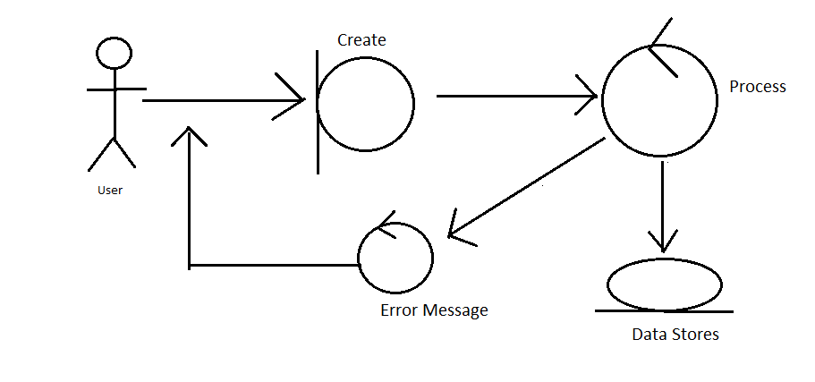

List

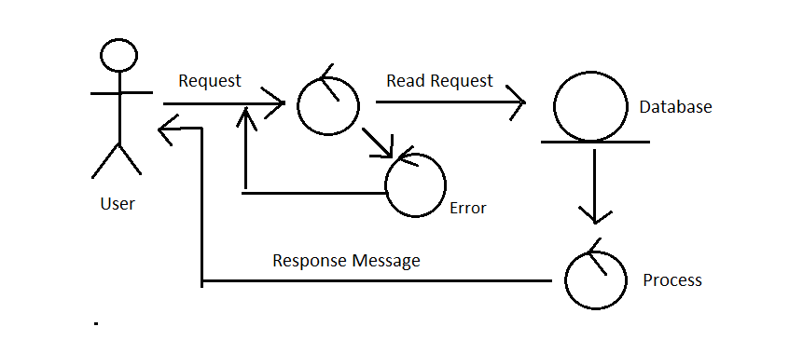

Delete

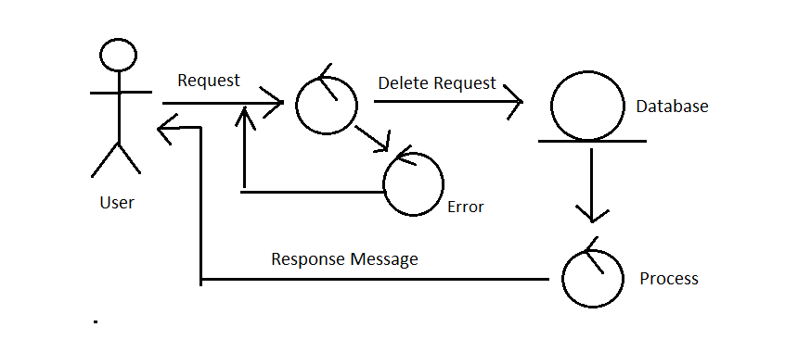

## Step-4: Class Diagram

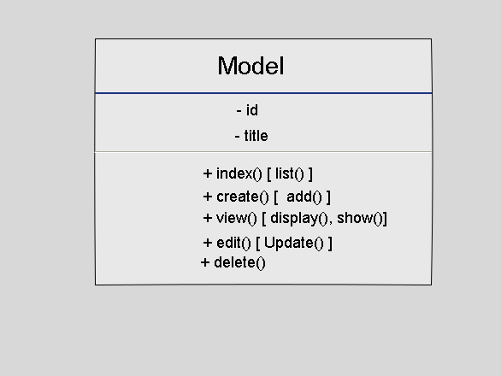

## Step-5: Sequence Diagram

Create/add /edit

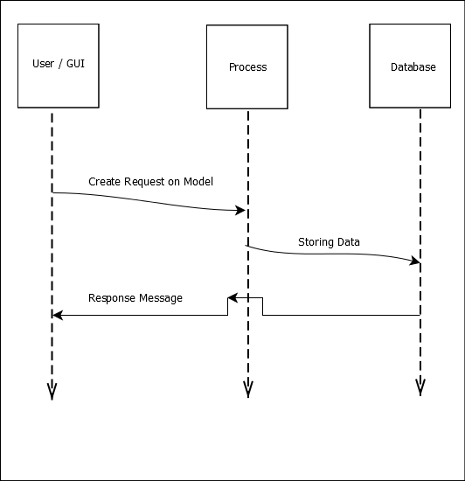

Read

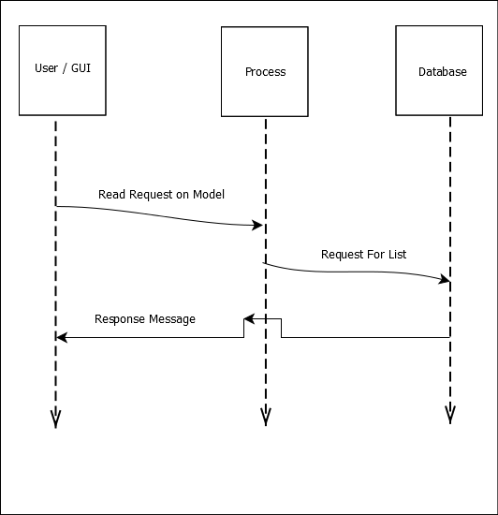

Delete:

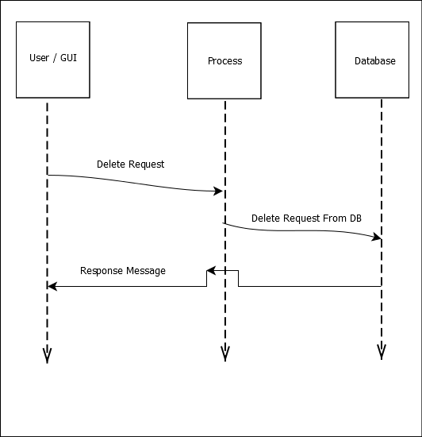

## Step-6: Schema Diagram

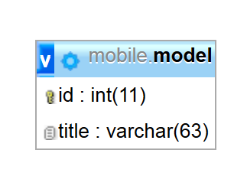

## Step-7: Mockup

Create:

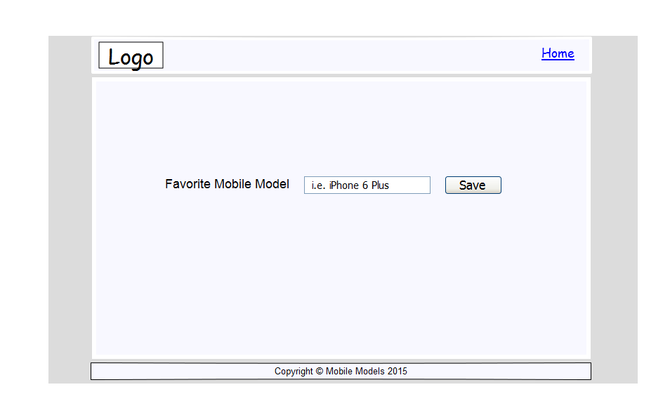

List

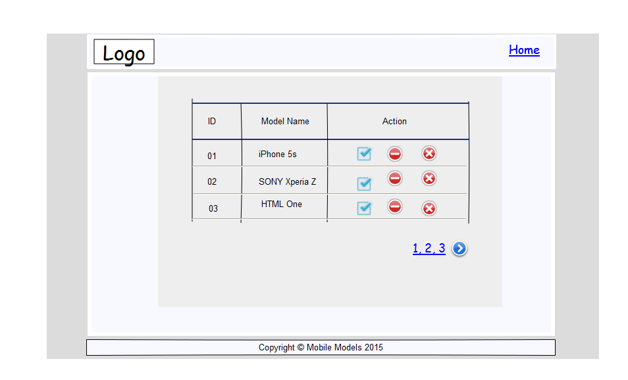

Edit

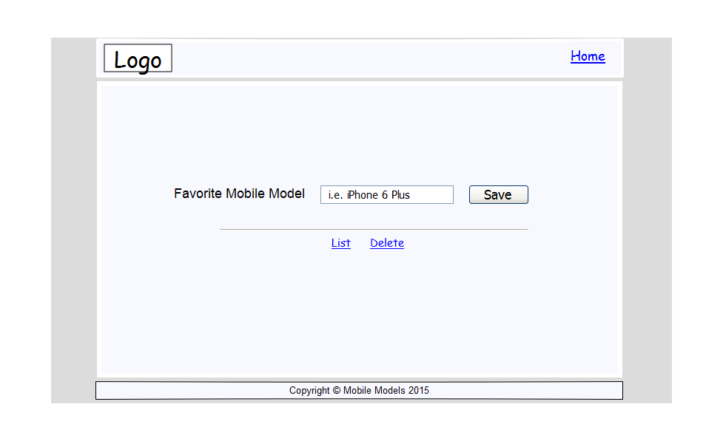

View

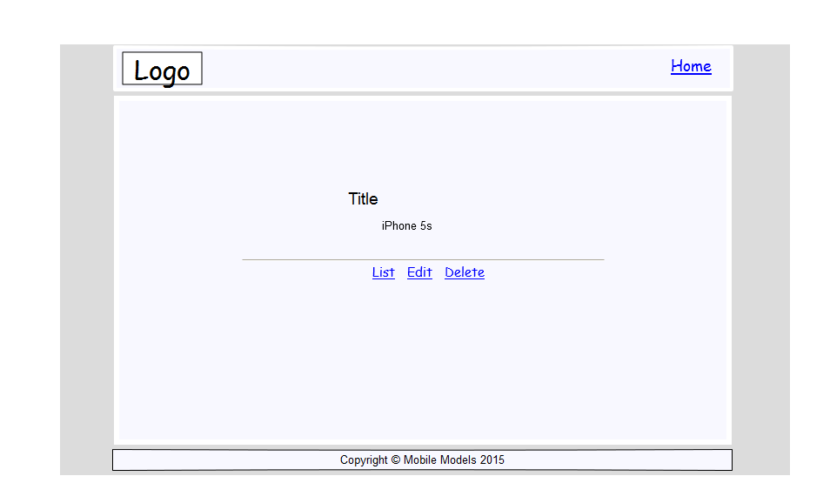

## Step-8: UI (HTML Coding)

## Step-9: Storage

9.1 PHP Coding (SESSION as Storage)

9.2 CSV File as storage

9.3 XML File as storage

9.4 MySql Database as storage.

## Step-10: Web API